**KAJJANSI HIGH SCHOOL**

**END OF TERM 1 2024**

**GEOGRAPHY S.5**

**TIME: 1HOUR: 30 MINS**

**INSTRUCTIONS**

* Attempt **ALL** questions in section **A** and one question in section **B**

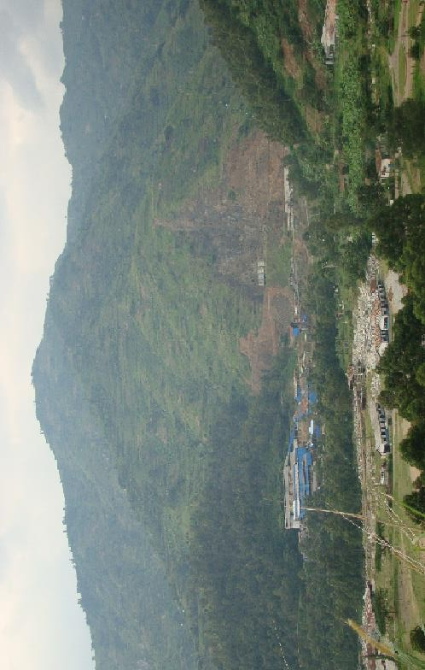 **PHOTOGRAPHY INTERPRETATIONS**

1. **COMPULSORY QUESTION, PHOTOGRAPHIC INTERPRETATION.**

Study the photograph provided below and answer the questions that follow:-

1. Draw a landscape sketch of the area shown on the photograph and on it, mark and name any:-
2. slopes
3. Vegetation types
4. Settlements **(09 marks)**
5. Describe the relationship between relief and land use in the area covered by the photograph. **( 06 marks)**
6. Giving evidence from the photograph, explain the problems faced by the people in the area **(08 marks)**
7. Giving reasons for your answer, suggest an area in East Africa where the photograph was taken. **(02 marks)**

**SECTION B**

**GEOMORPHOLOGY**

Attempt **one** question from this section

1. (a) What is continental drift? **(05 marks)**

(b) Examine the relevance of Wegener’s continental drift theory. **(20 marks)**

1. Examine the influence of tectonism on the development of lakes in East Africa.

**(25 marks)**

**End**